Parade Information
The official date of Batesville Community’s Tree Lighting and Holiday Parade is Friday, December 6th, 2019. This event will take place throughout downtown, from 5:00pm – 8:00pm. This exciting event is geared towards bringing the community together to celebrate the beginning of the Christmas season.
The Batesville Chamber Toyland Parade entries may consist of festive floats, bands, decorated vehicles, dance troupes, and community groups. We highly encourage all groups to prepare a float that is illuminated. Think of all the creative ways you could decorate the Toyland Theme with color, lights and sounds! Parade begins at 6:00pm.
DEADLINE FOR PARADE APPLICATIONS IS TUESDAY, DECEMBER 3RD.
For more information, please contact the Chamber at 812.934.3101 or chamber@batesvillein.com
Parade Route
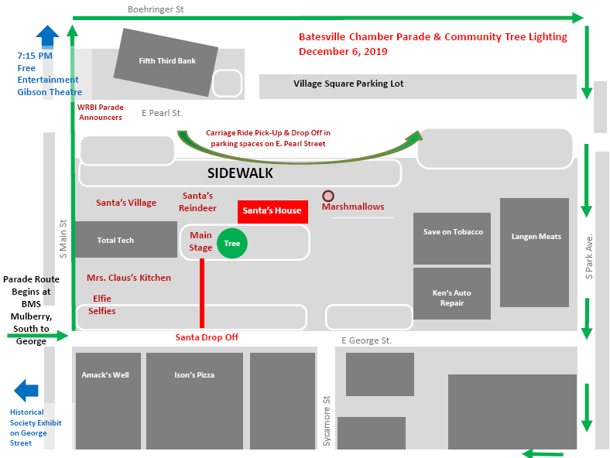

December 6^{th,} 2019 Parade Guidelines

REGISTRATION DEADLINE
We request that all registration forms be received by Tuesday, December 3rd, 2019.
All parade entries are FREE!

SHOW OFF YOUR FUR BABIES IN THE 1ST HOLIDAY DOG COSTUME EVENT
Dress up your dog and come join us in the Holiday Parade. We will have judges along the
route that will be watching for the BEST IN SHOW HOLIDAY COSTUME. Please be lined up
with your dog by 5:45pm.
A CLEAN UP CREW ALONG THE ROUTE MUST BE PROVIDED FOR ALL ENTRANTS OF LIVE
ANIMALS.

NO SANTAS ALLOWED
Santa will be the last entry in the parade. Please do NOT use a Live Santa on your float. This will only confuse small children watching for Santa at the end of the parade

FLOATS – Toyland Theme/Evening Parade
We highly encourage entries to be illuminated (lights, glow sticks, etc.). The theme for decorating is “Toyland”. Chamber Gift Certificates will be awarded to 1st, 2nd, & 3rd place floats. Float judging will begin at 5:30pm. The more lights, the merrier it will be!

PARADE LINE-UP
Parade line up opens at 5:00pm, at Columbus Avenue in front of the Batesville Middle School. Entries must be in place and ready to go by 6pm. Parade begins promptly at 6:00pm.

CANDY/PROMOTIONAL
Solicitation for cash or ticket sales along the parade route are not allowed. Candy may be gently tossed underhand into the crowd along the parade route, or handed out. If your group would like to hand out promotional material, it may be done person-to-person.

Toyland Parade Registration Form
REGISTRATION DEADLINE: December 3rd, 2019

Contact Information
Business/Organization Name: ____________________________________________________
Address: ______________________________________________________________________
Contact Person: _________________________________ Phone: _______________________
Email Address: _________________________________________________________________

Entry Type Choose only one
- Band/Choir
- Tractor or ATV
- Live Animals
- Other: _______________
- Single Vehicle
- Single Vehicle with Walkers
- Float/Trailer
- Walkers Only

Brief Description of Entry This will be used for Announcements along parade route
Example: “Merry Christmas from the Batesville Area Chamber of Commerce!”

__________________________________________________________________________________________________________________________________________________________________________________________________________________________________________

SUBMIT COMPLETED REGISTRATION FORM:
1) Mail or Drop off Entries to: 2) Email/Phone:
Batesville Area Chamber of Commerce chamber@batesvillein.com
301 Shopping Village, Batesville, IN 47006 812-934-3101

Addition Information: All parade floats must be illuminated.

