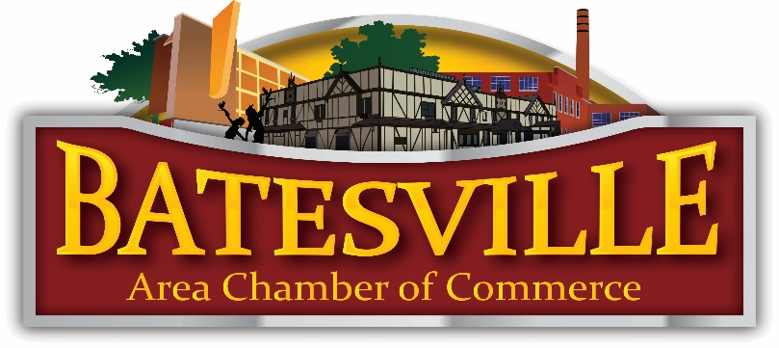

2020 Annual Award Nomination

I want to nominate him/her or organization for:
□ Distinguished Service Award – The most prestigious award recognizes an individual who has contributed outstanding efforts to the Community for a sustained period and at the very highest levels.
□ Educator of the Year – Impact on Students, Scholastic Knowledge & Educational Improvement.
□ Organization of the Year – Significant Impact & Service to our Community.
□ Volunteer of the Year – This award has been given out since 2006 to individuals who have gone above and beyond in their volunteer work with the Batesville Area Chamber of Commerce and/or Community.

Name: _______________________________________________________ Date: __________
Company: ___________________________________________________________________
Address: __________________________________________________ Phone #: _________
City: _________________________________________ State: ________ Zip: _____________

Nomination Submitted By: ______________________ Email Address: ________________
Address: __________________________________________________ Phone #:__________
City: _________________________________________ State: ________ Zip: _____________

On a separate sheet of paper please answer the following questions:

Background: Name of employer/organization where the nominee works, job title, occupation, recognition awards, and other biographical information about your nominee.
Description: Describe why your nominee deserves to be recognized for this award.

Attach your information to this sheet and return it by email (chamber@batesvillein.com), or drop it off at the Batesville Area Chamber of Commerce office. You can also download the form on our website: www.batesvillein.com. We will notify the winners and ask for additional information after we select the winners.
Return by Friday, December 31, 2019

Batesville Area Chamber of Commerce
301 Shopping Village, Batesville, IN 47006
Office 812-934-3101

The awards will be presented at the Batesville Area Chamber of Commerce Annual Dinner on Thursday, January 30, 2020 at Batesville Knights of Columbus.

